Vele Tosevski

1002174657

CSC 411

March 20, 2019

**HW5 Write-Up**

1. a)

Average Conditional Likelihood (Train Data): 28.686580

[[ 33.92402221 -88.45111834 -16.8932622 -25.83617441 -95.99459913 -28.0469699 -33.43930375 -128.00676019 -40.12341711 -120.7505451 ]

[ -68.22979333 43.8330528 -8.62313018 -41.79892253 -6.16921495 -42.54976231 -22.89991813 -33.06720503 4.20662396 -19.78080586]

[ -48.25937897 -55.92309386 16.88110064 -28.9959108 -65.50319452 -47.8188899 -54.71585182 -84.2803214 -35.97571408 -79.85123569]

[ -37.76535226 -60.50596233 -11.52881147 25.34749836 -80.23781057 -5.942891 -61.89235394 -74.20703712 -7.77750941 -63.81771045]

[ -63.57874438 -38.1128814 -27.37434988 -43.54955558 24.20650818 -37.62118033 -38.11452022 -49.30644691 -19.02665868 -3.93941094]

[ -31.92250461 -45.89294551 -23.0214228 0.2051562 -56.8635482 24.12660812 -36.96891002 -84.4180825 -2.6016538 -53.5127435 ]

[ -16.08499354 -65.52399532 -17.22797111 -38.51566436 -59.26386047 -19.90746009 29.24659472 -165.40709904 -29.97466814 -126.96745943]

[ -47.34810481 -22.74497808 0.17304175 -13.15842334 -22.22716495 -39.09215712 -80.81237908 38.53051509 -7.68591751 9.77505843]

[ -51.89004965 -33.31890348 -15.94135661 -21.54837236 -45.81703868 -18.8929108 -47.39728619 -66.1336154 20.02956548 -37.4736449 ]

[ -65.1618034 -46.64166345 -24.55400204 -32.3243134 -3.74088864 -39.22988767 -85.57166051 -7.67267147 -5.99624188 30.74033154]]

Average Conditional Likelihood (Test Data): 27.486200

[[ 33.21271943 -85.10474932 -14.92668303 -25.03919668 -92.24055178 -28.41301758 -31.98166934 -121.11671514 -38.9435702 -115.68602049]

[ -65.98273597 43.75667838 -7.89988668 -40.78305048 -4.21465107 -41.85439817 -19.49559598 -27.26307905 5.51581709 -17.43312634]

[ -48.40011136 -56.79648782 15.76987273 -32.02961238 -64.05056948 -48.58909001 -52.90835733 -87.94971095 -36.4708241 -81.13238684]

[ -36.61811894 -59.0998393 -10.81252291 23.18843659 -79.32152079 -5.49772638 -60.31175001 -75.53668363 -8.21771127 -64.68566461]

[ -63.6224916 -38.31251625 -27.68532145 -42.79967361 23.16501442 -36.98680559 -38.8213785 -48.45629329 -19.54241646 -2.7608024 ]

[ -28.61602964 -40.69825848 -20.36105698 3.672266 -55.92112179 24.03785909 -32.49333123 -81.85722903 -1.63104965 -53.09672336]

[ -17.94182886 -70.13173546 -19.32409691 -40.17621616 -61.330969 -20.45038953 26.35234161 -169.74575806 -30.4058043 -128.24679529]

[ -48.50416378 -22.52592109 -0.48298009 -13.97483349 -20.82250406 -38.86921001 -81.1159767 37.69449875 -8.12088509 9.78420061]

[ -53.05155379 -34.54053281 -17.60860408 -22.40460407 -46.75337517 -19.61290705 -49.00099401 -68.0970773 18.6596498 -38.65401494]

[ -64.02644638 -46.67289562 -22.92041583 -30.60657673 -4.95359756 -38.41795983 -86.48303501 -6.37184554 -5.88093645 29.02492862]]

b) Accuracies -> Train: 98.143% (Rounded)

Test: 97.275%

c) The following figure is the figure of eigenvectors of the Covariance matrices for each digit:

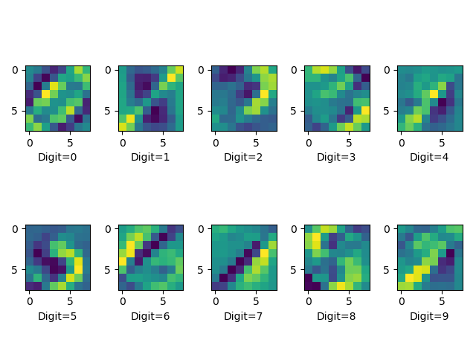

Figure 1: Covariance Eigenvalues for each Digit (Axes are pixel number)

